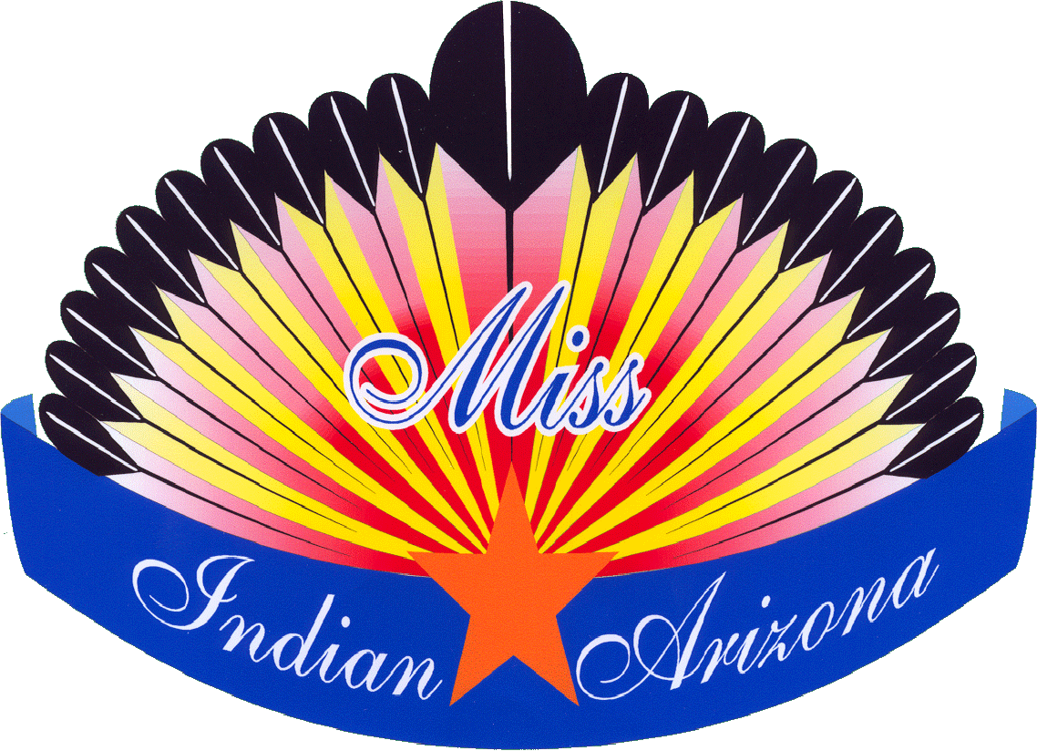

Miss Indian Arizona Scholarship Program

Greetings!

Thank you for your interest in participating in the Miss Indian Arizona Scholarship Program. Enclosed, you will find materials that describe our eligibility requirements, application materials, as well as regulations and expectations of Miss Indian Arizona and her court.

This packet is composed of several sections, each of which deals with a particular aspect of our program. These are:

- Eligibility Criteria – Participants in the Miss Indian Arizona Scholarship Program must meet the listed criteria
- MIA Regulations – These regulations must be followed by Miss Indian Arizona, as well as the 1st and 2nd Attendants
- Scholarship Rules – These rules apply to scholarship funds awarded to Miss Indian Arizona, as well as the 1st and 2nd Attendants
- MIA Duties – These are the duties that Miss Indian Arizona and her court will be expected to fulfill
- Program Rules – These rules pertain to the Scholarship Program, and should be read thoroughly. Failure to comply with these rules could potentially result in lost points or disqualification.
- Application Checklist – Using this checklist will help you ensure that your application packet is complete
- Application – Participants must fill out the 3 page application completely. You are also required to submit the following forms, which are included, as a part of your application:
Physician’s Statement
Parental Acknowledgement
Description of Talent
Description of Traditional Dress
Essay requirements
Community service paper requirements
You must also submit the following documents with your application:
Two letters of recommendation
Proof of tribal enrollment
Copy of official grade transcripts
Description of your Community
Color photo in tribal dress in two sizes
TIPS FOR COMPLETING YOUR APPLICATION MATERIALS

Your MIA application materials not only serve as your first impression to the program judges, they also assist us in presenting you accurately throughout the scholarship program. Therefore, your aim should be to complete all materials truthfully and in a manner that reflects your best assets and attributes.

Use the following tips to ensure that your application is completed correctly while putting your best face forward!

You can access the Miss Indian Arizona application on line at: www.missindianarizona.com. Using this site will allow you to produce a much neater application.

Take your photos in an interesting location, such as a scenic location on your reservation, or a nice part of your home. Please do not send studio portraits. However, remember the following guidelines:

- Take the picture in a bright spot but not direct sunlight. Direct sunlight results in harsh shadows and washed out areas in your picture.

- Phone camera pictures are not acceptable.

- For the print, make sure that this is from an actual photo processor, such as Target, Wal-Mart, Walgreens, etc. Printouts from your home printer are not acceptable.

- Stand or pose in an interesting, but natural way.

- Make sure that your body takes up most of the picture, and that you eliminate any unnecessary space in the frame.

Remember that incomplete application packets will not be accepted. Make sure you use the application checklist to ensure you are completing everything that is required.

Give yourself plenty of time to complete your packet before the deadline. Some items (such as the essays) take longer to complete than others, and some items require input from other people who may not have the same schedule as you do.

MISS INDIAN ARIZONA ELIGIBILITY CRITERIA

- You must be an enrolled member of a federally recognized tribe within the State of Arizona, a resident of Arizona, and must be tribally sanctioned by the Arizona tribe you are representing.
- You must be at least seventeen (17) years of age and be no older than twenty-four (24) years of age at the time of the Miss Indian Arizona Scholarship Program.
- You are and you have always been a female.
- You are not now and you have never been married.
- You are not now pregnant, and you have never been pregnant. You are not the adoptive parent of any child.
- You are of good moral character and have not been involved at any time in any act of moral turpitude.
- You have never been convicted of any criminal offense, and there are no criminal charges presently pending against you.
- You do not use, possess, or consume any illegal controlled substances or abuse the use of alcohol or other dangerous substances.
- You are in good health and can, to the best of your knowledge, participate fully and without limitation in any Program activities. Any current medical condition or disability will not impede your ability to complete your year of service or fulfill your obligations.
- You must be knowledgeable of your culture, history, values, traditions and issues of your tribe and current issues of all Arizona Tribes.
- You must have a high school diploma or GED or be currently attending high school, GED classes, college or technical school and plan to continue your education toward obtaining a degree. You must have a grade point average of 2.0 or higher (on a 4.0 scale).
- You must not be registered for active duty with any military service.
- You must not have previously held the title of Miss Indian Arizona.
- You must be willing and able to communicate with the public.
- You must comply with all program requirements, rules, and regulations.
- You must participate in all program activities.

Miss Indian Arizona Regulations

Participants must read these regulations carefully to understand and prepare for participation in the Miss Indian Arizona Scholarship Program. Miss Indian Arizona and her court represent themselves, their families, and all Indian people in the State of Arizona and are expected to uphold their titles with respect, honor and dignity. Miss Indian Arizona and the 1st and 2nd attendants must adhere to the following regulations:

- Must maintain Arizona residency throughout the year of service.
- Traditional dress must reflect the Arizona tribe that they represent.
- Shall serve for one year.
- Will travel as designated by the Miss Indian Arizona Association and will travel with a chaperone approved by the Association
- Must not marry or cohabitate during the year of their reign.
- Must not become pregnant during the year of their reign.
- Must not be seen in bars, frequent liquor establishments, use alcohol or illegal drugs, including tobacco products or use profanity at anytime during their rein.
- Pregnancy, incarceration or conviction of a crime shall be immediate cause for relinquishment of Miss Indian Arizona titles. In the event of relinquishment all benefits, royalties, gifts, and honors derived from the scholarship program and reign shall be returned to the Miss Indian Arizona Association.

- Must not seek any other title during reign as Miss Indian Arizona.

- Must relinquish any titles or crowns if chosen as Miss Indian Arizona. Waivers may be requested.

MISS INDIAN ARIZONA SCHOLARSHIP AWARD RULES

Participants are responsible for reading/complying with all scholarship rules.

These rules apply to Miss Indian Arizona and the First and Second attendants.

Scholarship funds shall be expended for tuition and related educational expenses. Room/board and other educational expenses must be approved by the Executive Director of the Miss Indian Arizona Association. Room /board will not be reimbursed for contestants living at home or with relatives.

Requests for scholarship funds are processed upon receipt of statements from colleges/schools or individual for educational expenses. All statements and invoices must be accompanied by a cover letter from the participant.

Scholarship funds may be used for current educational expenses. Participants may submit invoices for payment directly to the provider of the educational service or may submit a receipted bill and request reimbursement. All invoices and receipts must be originals.

Scholarships may be used for future education expenses. Participants must begin use of their scholarships within one year of the date of the award. If a contestant has no activity in her scholarship account during this period, the funds in her account will be forfeited.

A participant, who begins use of her scholarship within time designated above, will be required to show continuous activity in her scholarship endeavors up to the limit of four years following the date of the award.

An exception to the time limits described above may be made if a participant, prior to the four year expiration date, makes a written appeal to the Miss Indian Arizona Association citing compelling reasons for the time extension. The Association will review request and determine if an extension is warranted.

Scholarships, which have been forfeited, will remain in the scholarship account for future awards.

All Association decisions are final and binding.

MISS INDIAN ARIZONA DUTIES

- Miss Indian Arizona (MIA) and her court will always be positive role models and are expected to conduct themselves at all times in a manner above reproach.
- Miss Indian Arizona or the first or second attendant will appear on time at all scheduled events. Should an emergency arise which prevents an appearance, immediate notification will be made to the Miss Indian Arizona Association (MIAA) Executive Director.
- Miss Indian Arizona will set a goal related to her platform that can be reasonably achieved during her reign in the area of community service. The goal must be submitted to the Miss Indian Arizona Association within 90 days of her crowning.
- Miss Indian Arizona is responsible for the care and safe-keeping of the crown and sash during her reign and is financially responsible in the event of loss or damage to the crown. The crown is a perpetual crown, which will be handed down to the next MIA and remains the property of the Miss Indian Arizona Association.
- Miss Indian Arizona is considered a member of the Miss Indian Arizona Association and will present a written quarterly report to the Miss Indian Arizona Association during regular scheduled meetings.
- Miss Indian Arizona will take an active role in recruiting future participants in the Miss Indian Arizona Scholarship Program.
- Miss Indian Arizona is responsible for planning and executing her farewell event to be completed before September 15th of her reigning year. Thirty-day notice of the event will be given to the Miss Indian Arizona Association.

MISS INDIAN ARIZONA SCHOLARSHIP PROGRAM RULES

Participants will be judged in seven categories: Personal interview, talent, evening dress, traditional dress, oral presentation, essay and community service paper.

The Miss Indian Arizona application must be signed by a “Tribal Council Executive”. Tribal council executive includes the highest elected officials of the Tribe, i.e. Governor, President, Chairman/person, Lieutenant Governor, Vice-President, Vice-Chairman/person, or other designated tribal executive. Should more than one application be received from the same Tribe, the first complete application received will be the tribal participant.

Miss Indian Arizona Scholarship Program participants must be on time for all scheduled events (i.e., workshops, activities, rehearsals, etc.) unless advance permission is granted for an absence by the Miss Indian Arizona Association.

A three-minute talent presentation is required. The talent presentation may be either traditional or contemporary in nature (i.e., singing, dancing, explanation of a tradition of your tribe, etc). You may use pre-recorded music as background to your presentation. You must provide a CD clearly marked with your name for rehearsal and program use. Make sure your CD is recorded very clearly and is queued. No other individual will be allowed on stage during the talent presentation. Any accompaniment must be off stage. Presentations, which are over three minutes, will be penalized 10 points.

The use of stage props will be limited to those that will be physically utilized by the participant. All props must be approved by the Program Director.

You must provide a written description of your talent presentation which will be used in your introduction.

A three-minute oral presentation based on the Scholarship theme is required. Oral presentations are spoken words. Oral presentations shall not include the following: singing, sign language, dancing or audience involvement. Oral presentations over three minutes will be penalized 10 points.

The use of video, power point and/or slide projection is not allowed in any presentation.

You must provide a description of your traditional dress. The description should have a minimum of 120 words and a maximum of 180 words. The description may be edited by scriptwriter for timing. Any changes will be discussed with the participant.

You must submit an essay based on the scholarship theme. The essay must be at least 300 words and no more than 500 words.

You must submit a paper describing your community service work. The community service paper must be accompanied by a verification letter from someone in the organization, on organization letterhead.

You must submit a brief description of your community.

Miss Indian Arizona Scholarship Program Application Checklist

THE FOLLOWING ITEMS MUST BE INCLUDED WITH YOUR APPLICATION:

___________ COMPLETED SCHOLARSHIP APPLICATION. The application must be signed by a “Tribal Council Executive”. Tribal Council Executive includes the highest elected officials of the Tribe, i.e. Governor, President, Chairman, Lieutenant Governor, Vice-President, Vice-Chairman, or other designated tribal executive.
___________ APPLICATION ENTRY FEE:
$250 IF POSTMARKED ON OR BEFORE JUNE 25th
$350 IF POSTMARKED AFTER JUNE 25th
.
Final date for submission of applications is August 8th.
**NO REFUNDS**
___________ Official MIAA Physician’s statement
___________ Parental Acknowledgment Form
___________ Description of Talent
___________ Description of Traditional Dress
___________ Essay based on Scholarship Theme
___________ Community Service Paper
___________ Two letters of recommendation
___________ Proof of Tribal Enrollment
___________ Copy of official grade transcripts
___________ Community Description
___________ Color photo in tribal dress in two sizes:
1 - 8” x 10” color photo. Home printouts on photo paper are NOT acceptable
1 - Photo in digital format (at least 800x600, JPG, PNG or TIFF only)

Mail completed application with this checklist to:

Miss Indian Arizona Association
16035 S. 31st Way
Phoenix, AZ 85048

Tel: (480) 306-4533 Fax: (480) 306-8505
missindianazassoc@cox.net

DEADLINE – JUNE 25th ($250)
LATE DEADLINE – JUNE 26th - AUGUST 8th ($350)

THIS CHECKLIST MUST BE RETURNED WITH THE APPLICATION

Miss Indian Arizona Scholarship Program Application

- PERSONAL INFORMATION

Full Name Age DOB HEIGHT_________
Mailing Address

City State Zip Code

Home Phone ( ) Cell Phone ( )
Email Address @
Tribe of Enrollment Enrollment #
Other Tribal Affiliations (if any)
Mother’s/Legal Guardian’s Name:
Father’s/Legal Guardian’s Name:
Number of Brothers and Sisters:

- EDUCATIONAL BACKGROUND

Status: □ High school student
□ College student
□ Not currently in school Current GPA

Provide information for all levels of education completed or in progress:
Name of High School/GED Program Graduation Year
Name of College/University Graduation Year
Type of Program □ Certificate Program
Pursued: □ Associate’s Degree
□ Bachelor’s Degree
□ Master’s Degree

Area(s) of Study

Other training completed or in progress
- EMPLOYMENT INFORMATION

Job Title: Employed From: to
Name of Employer: City: State:

- GOALS, ACHIEVEMENTS AND ADDITIONAL INFORMATION

What are your personal and educational goals?

What awards or special recognition have you received in or outside of school? (You may attach a resume)

What are your interests and hobbies?

What platform do you plan to promote if selected as Miss Indian Arizona?

- CERTIFICATION OF INFORMATION AND REQUIRED SIGNATURES

I have read and understand all rules and regulations of the Miss Indian Arizona Scholarship Program and certify that the information I have provided for consideration is complete and accurate to the best of my knowledge. I understand that any false, erroneous or incomplete information may result in my disqualification.

I also understand that I am responsible for my personal belongings at all times during the scholarship program and its related events. The Miss Indian Arizona Association is not liable for any damage, loss or theft of belongings or bodily injury sustained during said events.

I understand that all Association decisions are final and binding.

Signature of Participant Date

By signing below, I acknowledge that the participant above is an enrolled member of my tribe. I understand that the Miss Indian Arizona Association has limited financial resources, and can only fund travel within the State of Arizona.

I also understand that should the participant above be selected as Miss Indian Arizona, the Miss Indian Arizona Association will be requesting a financial contribution from my tribe to help pay for out of state travel expenses for Miss Indian Arizona.

Signature of Tribal Council Executive Date

( )
Printed Name of Council Executive Phone Number of Council Executive

OFFICIAL PHYSICIAN’S STATEMENT

Participant’s name:

I hereby certify that on this date I have examined the above named participant, and that she:

□ was given a pregnancy test and the results were negative.

□ is physically able to participate in all activities of the Miss
Indian Arizona Scholarship Program with no restrictions.

Provider’s Signature: Date:

Provider’s Name:
Please print

Provider’s Phone #

Additional comments:

This original form must be filled out by an M.D., D.O. or a Certified Nurse Practitioner.

MISS INDIAN ARIZONA
PARENTAL/GUARDIAN ACKNOWLEDGMENT FORM

We/I do hereby certify that ________________________________________ has my/our permission to participate in the Miss Indian Arizona Scholarship Program.

We/I acknowledge we/I have read and understand the “Eligibility Criteria” and “Rules and Regulations” of the Scholarship Program, and do agree with all the requirements and do submit that all these guidelines will be adhered to.

We/I acknowledge that all Association decisions are final and binding.

________________________________________________ _________________________
Signature of Parent/Guardian Date

Please Print Name: _______________________________________________

Address/Street Number: _________________________________________

City/State: ________________________________________ Zip Code: _______________

Home Location: ________________________________________

DESCRIPTION OF TALENT

A three-minute talent presentation is required. The talent presentation may be either traditional or contemporary in nature (i.e., singing, dancing, explanation of a tradition of your tribe, etc). You may use pre-recorded music as background to your presentation. You must provide a CD clearly marked with your name for rehearsal and program use. Use the space below to explain your talent.

Name:

DESCRIPTION OF TRADITIONAL DRESS

You must provide a description of your traditional dress. This description is used to write the script for the traditional dress portion of the evening program. Include any information you feel is relevant, such as the methods used to make the clothing, the meaning of certain articles, or celebrations that the dress is worn for.

Use the space below to describe your traditional dress. The description should have a minimum of 120 words and a maximum of 180 words, and may be edited by scriptwriter for timing. Any proposed changes will be discussed with you.

Name:

ESSAY COMPETITION

Participant must write an essay which reflects the program theme.

Essay must contain a cover page which contains the Title of the essay, participants name and Tribal affiliation.

Format of the essay: No less than 300 words or more than 500 words, typed and double spaced.

Essay must be clear, organized and effective.

Essay must reflect the use of good grammar and punctuation.

Essay must flow smoothly and logically.

Essay conclusion must be logical.

COMMUNITY SERVICE PAPER

Participant must write a Community Service paper which should describe her involvement in Community Service/Volunteer work. The paper should include the following:

- A cover page with the participants name and tribal affiliation.
- Quality of service participant has provided.
- Effects of service upon the community and the individual.
- The participant’s commitment to the service.

The Community Service Paper must be accompanied by a letter from someone in the organization verifying participant performed the community service work. The verification letter must be on the organizational letterhead.

